**Lab 4**

**To Simplify Boolean Expressions and Implement Respective Digital Circuits Using Karnaugh Map**

**Note:** For examples, refer to the following link: <https://www.geeksforgeeks.org/introduction-of-k-map-karnaugh-map>

**Tasks**

1. **Construct K-Map for the function given below. Show the simplified output expression and verify the output with the help of software simulation.**

Z = f(A,B) = http://www.ee.surrey.ac.uk/Projects/Labview/minimisation/graphics/a.gifhttp://www.ee.surrey.ac.uk/Projects/Labview/minimisation/graphics/b.gif + A http://www.ee.surrey.ac.uk/Projects/Labview/minimisation/graphics/b.gif + http://www.ee.surrey.ac.uk/Projects/Labview/minimisation/graphics/a.gifB

K-Map

**B**

**A**

|  |  |
| --- | --- |
| m0 | m1 |
| m2 | m3 |

Group#2

**B**

**A**

|  |  |
| --- | --- |
| 1 | 1 |
| 1 | 0 |

Group#1

Simplified Output Function

F = A’ + B’

Software Simulation of Logic Circuit From Simplified Function

(Show here your results for each combination that is present in the Boolean expression)

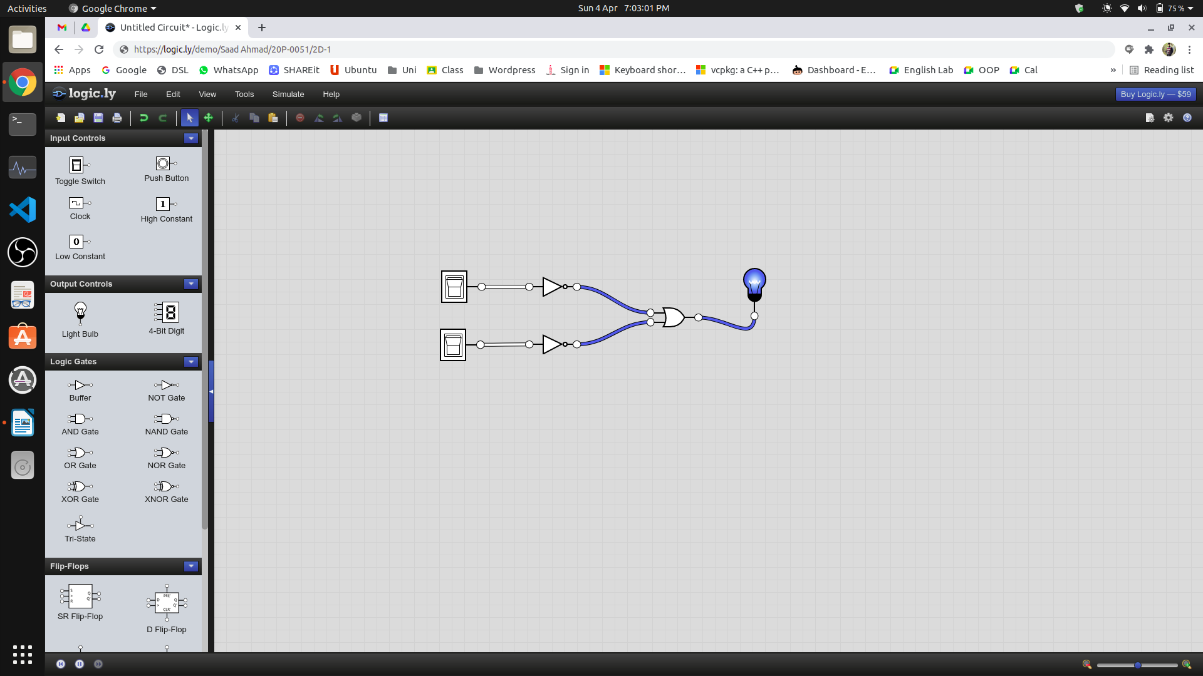

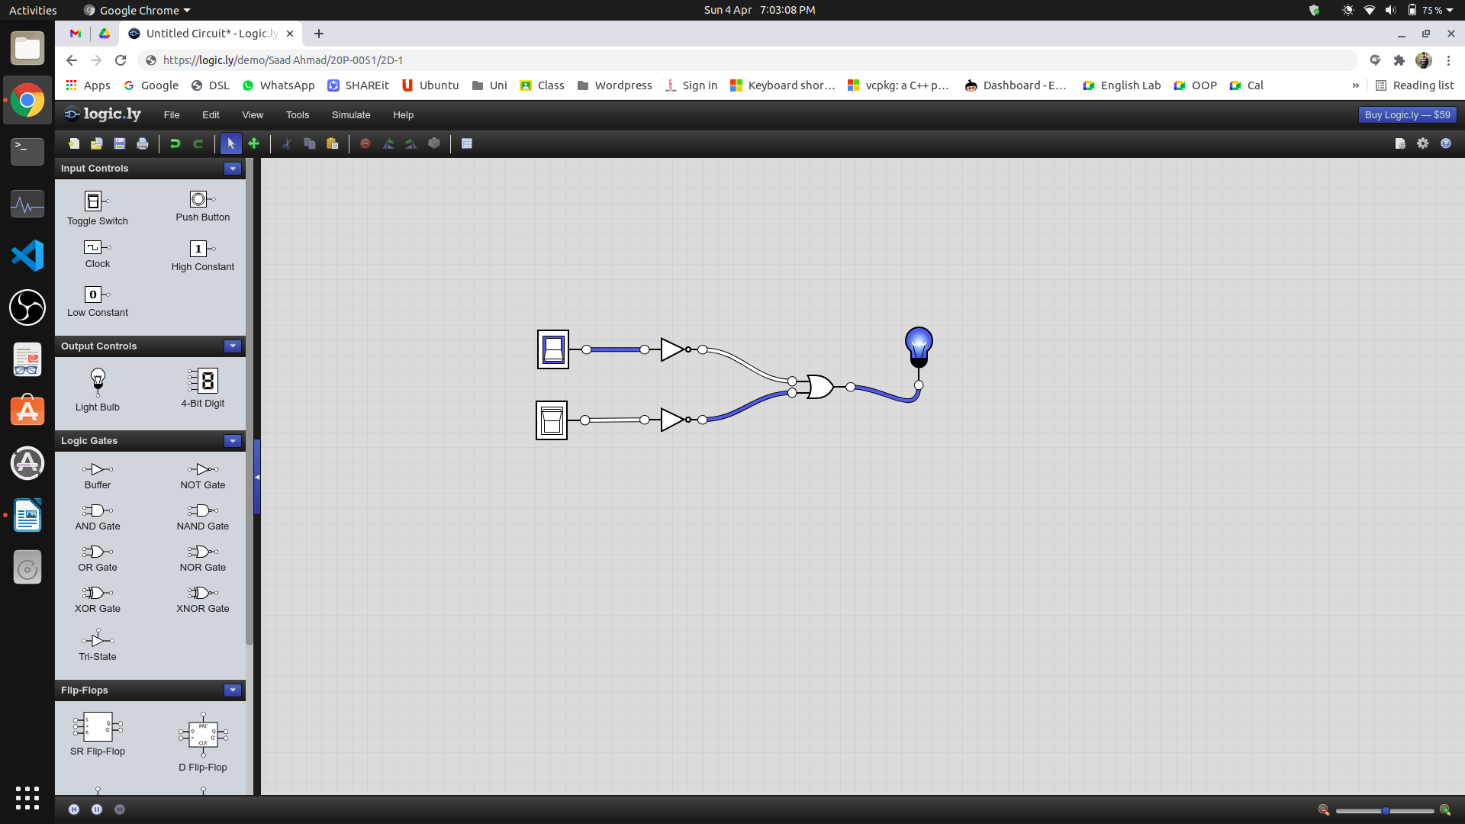

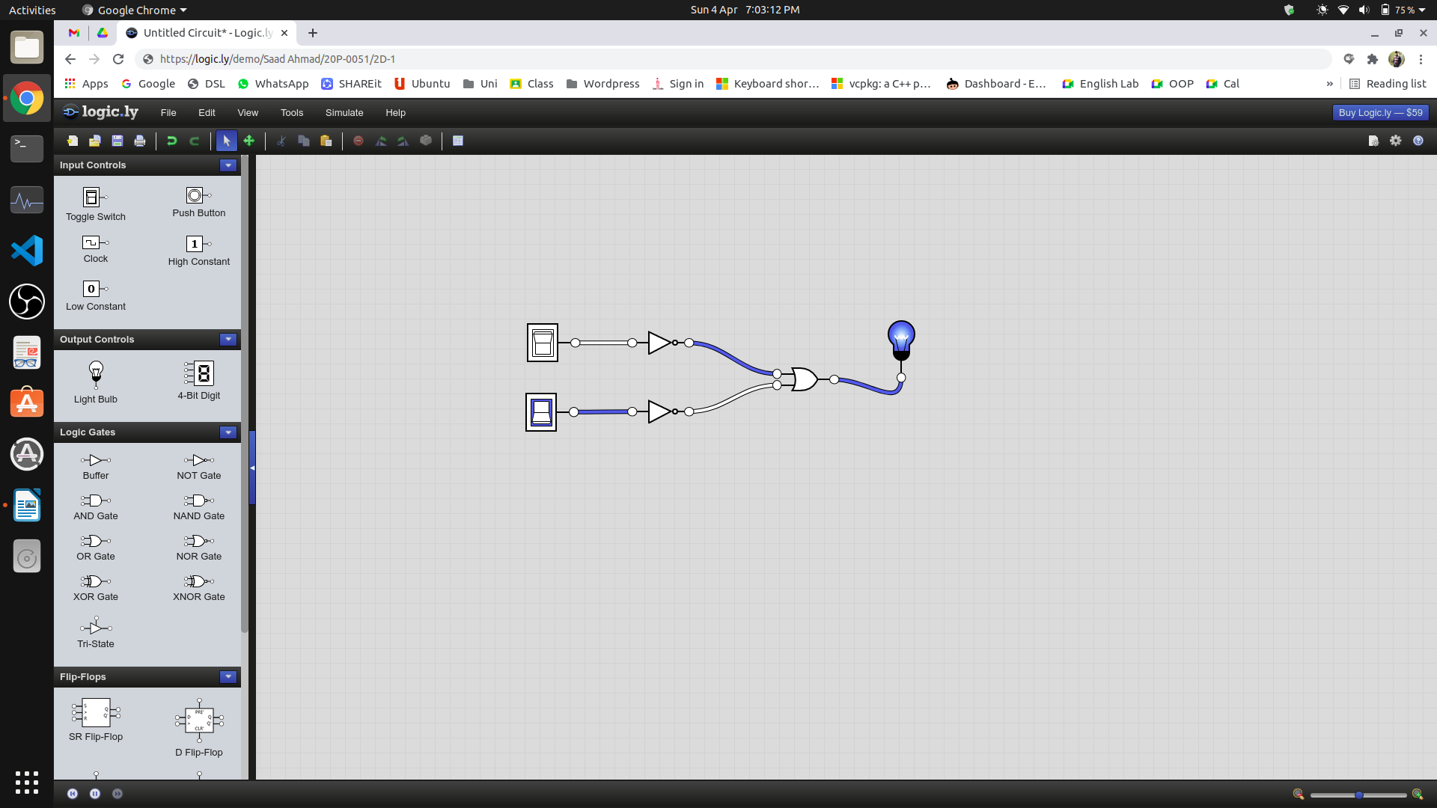

1. **Minimize the following function using K-Map. Verify the output expression with the help of simulation.**

f(a,b,c,d) = m(3,7,11,12,13,14,15)

K-Map

**CD**

|  |  |  |  |
| --- | --- | --- | --- |
| m0 | m1 | m3 | m2 |
| m4 | m5 | m7 | m6 |
| m12 | m13 | m15 | m14 |
| m8 | m9 | m11 | m10 |

**AB**

Group#1

**CD**

|  |  |  |  |
| --- | --- | --- | --- |
|  |  | 1 |  |
|  |  | 1 |  |
| 1 | 1 | 1 | 1 |
|  |  | 1 |  |

**AB**

Group#2

Simplified Output Function

F = CD + AB

Software Simulation of Logic Circuit From Simplified Function

(Show here your results for each combination that is present in the Boolean expression)

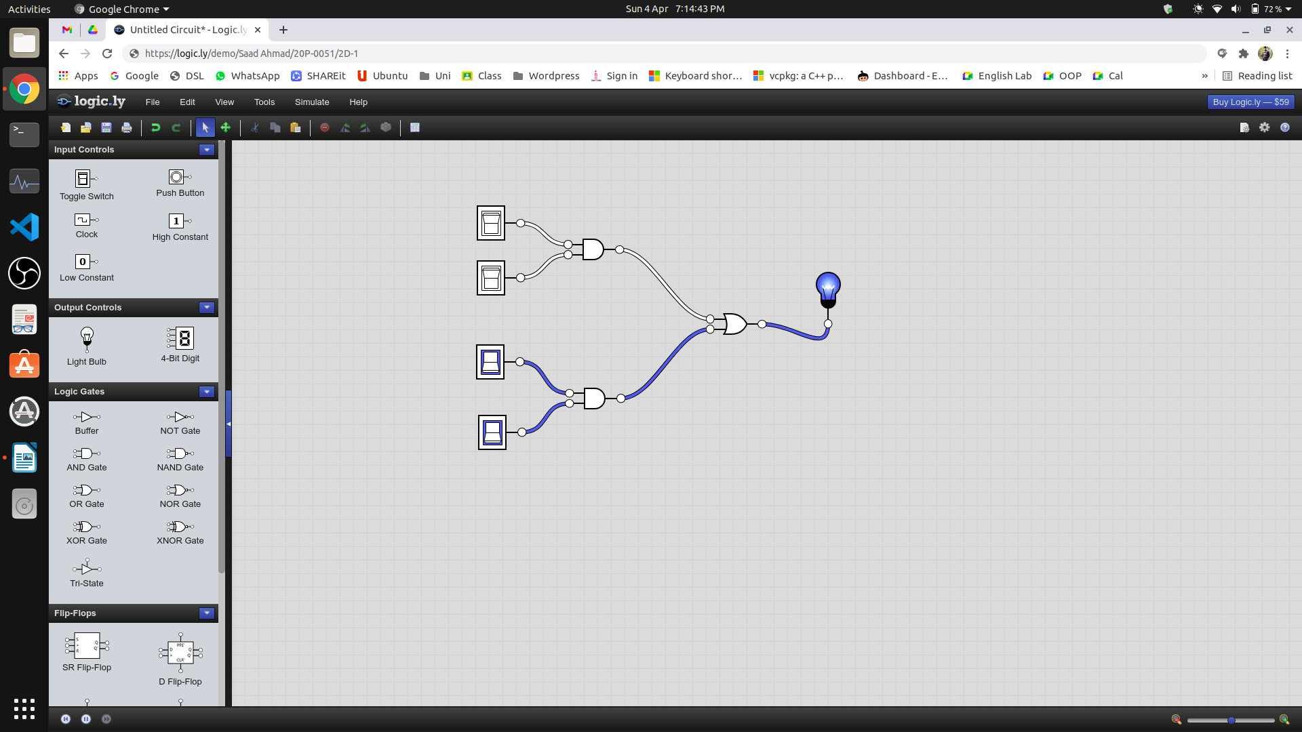

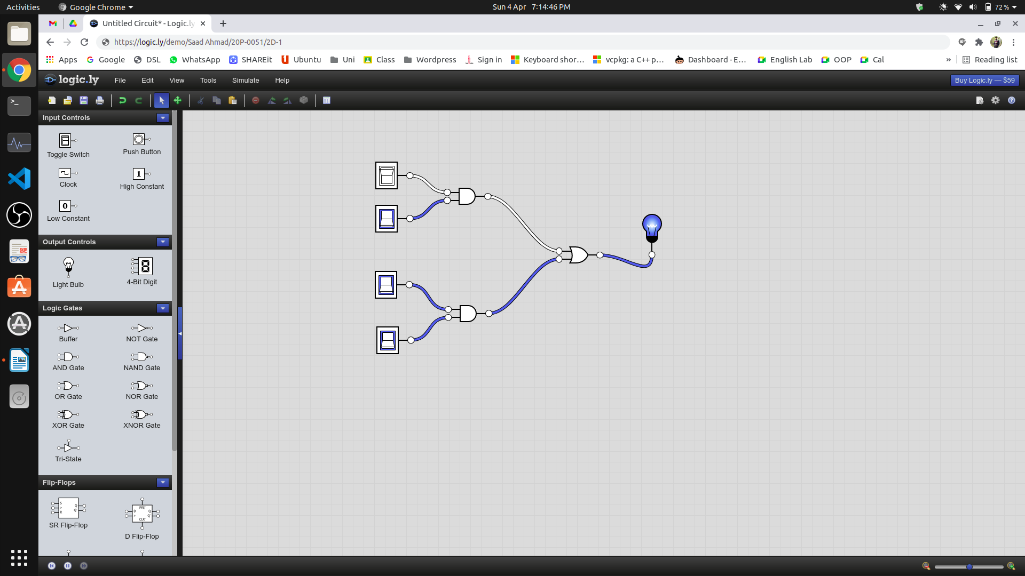

1. **Construct K-Map for the given POS form given below. Simulate your final expression (reduced) and show the results.**

F(A,B,C,D)=**π**(3,5,7,8,10,11,12,13)

K-Map

**CD**

|  |  |  |  |
| --- | --- | --- | --- |
| M0 | M1 | M3 | M2 |
| M4 | M5 | M7 | M6 |
| M12 | M13 | M15 | M14 |
| M8 | M9 | M11 | M10 |

**AB**

Group#2

Group#3

**CD**

|  |  |  |  |
| --- | --- | --- | --- |
|  |  | 0 |  |
|  | 0 | 0 |  |
| 0 | 0 |  |  |
| 0 |  | 0 | 0 |

**AB**

Group#1

Group#4

Simplified Output Function

F = ( C + D + A’ ) . ( B’ + C + D’ ) . ( C’ + D’ + A ) . ( A’ + B + C’ )

Software Simulation of Logic Circuit From Simplified Function

(Show here your results for each combination that is present in the Boolean expression)

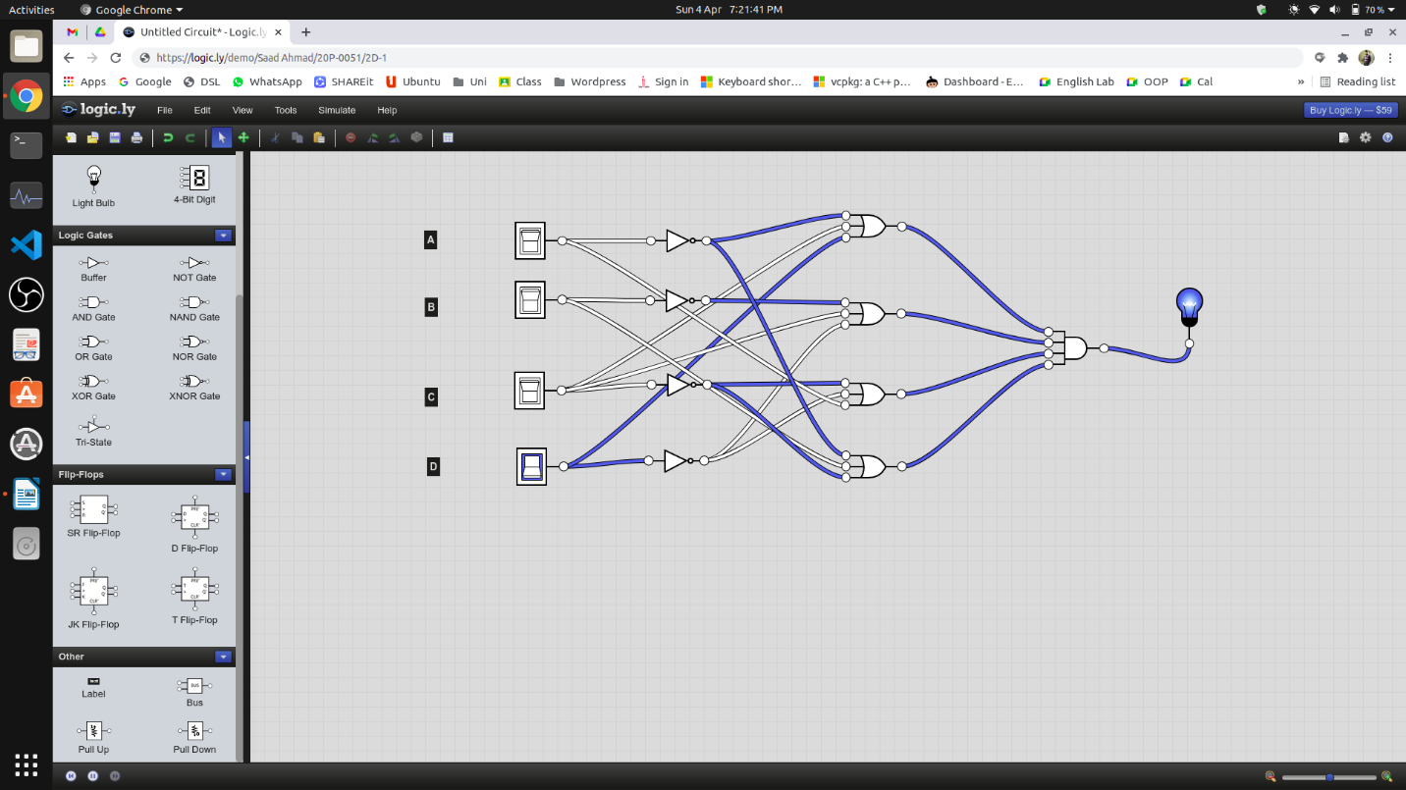

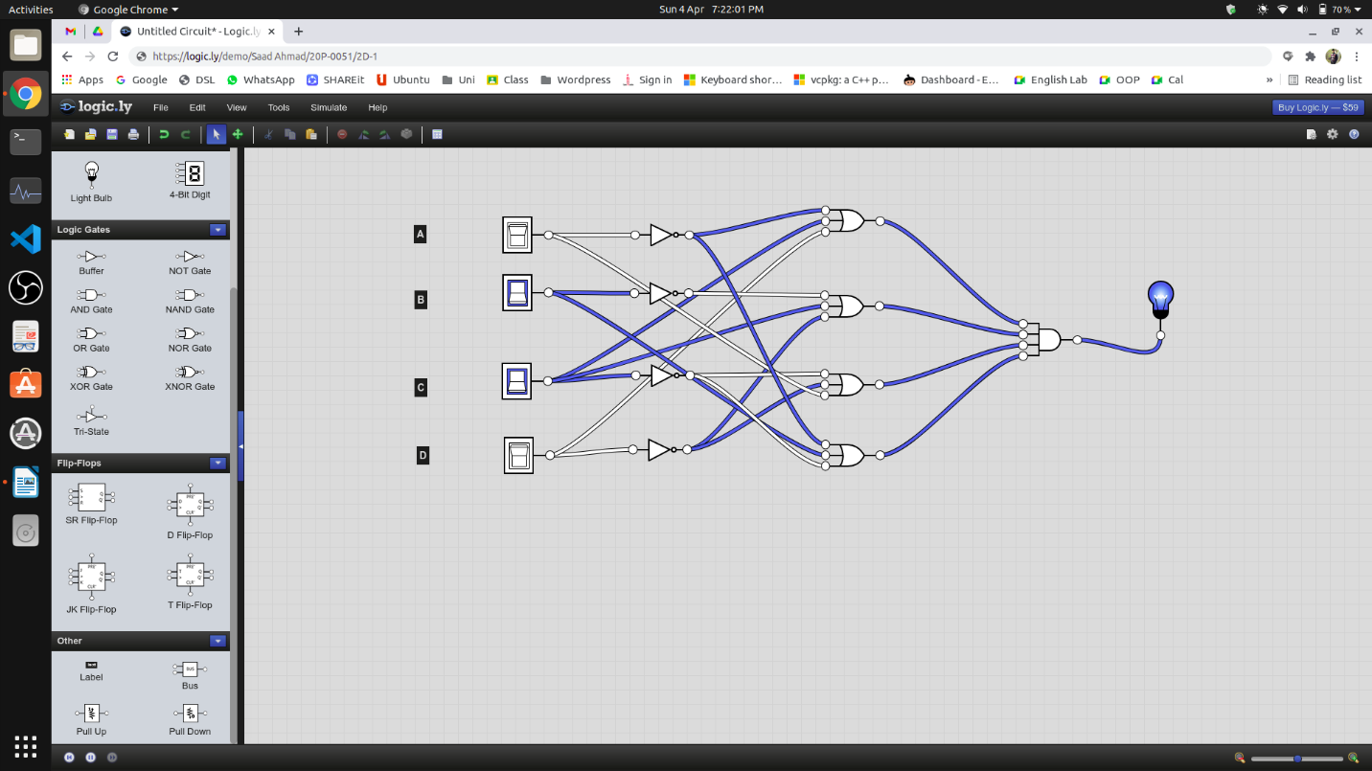

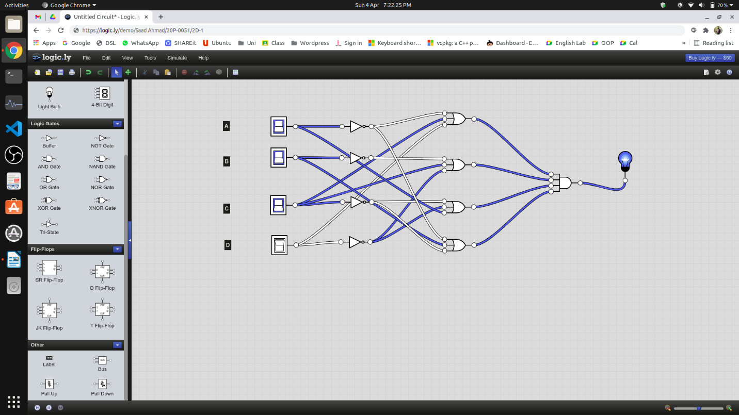

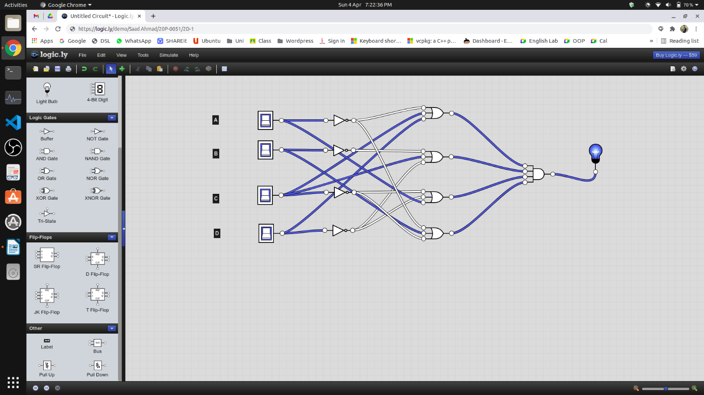

1. **Devise a minimized expression for the given truth table using K-Map (SOP form).**

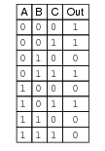

K-Map

**BC**

|  |  |  |  |
| --- | --- | --- | --- |
| m0 | m1 | m3 | m2 |
| m4 | m5 | m7 | m6 |

**A**

Group#1

**BC**

|  |  |  |  |
| --- | --- | --- | --- |
| 1 | 1 | 1 |  |
|  | 1 |  |  |

**A**

Group#2

Expression

Out=

F = A’ + B’C

1. **For the above truth table, devise an expression in POS form using KMap.**

K-Map

**BC**

|  |  |  |  |
| --- | --- | --- | --- |
| m0 | m1 | m3 | m2 |
| m4 | m5 | m7 | m6 |

**A**

Group#2

**BC**

|  |  |  |  |
| --- | --- | --- | --- |
|  |  |  | 0 |
| 0 |  | 0 | 0 |

**A**

Group#3

Group#1

Expression

Out=

F = (A’+B+C) . (A’+B’) . (B’+C)

1. **Devise a truth table and Boolean expression for the given K-Map.**

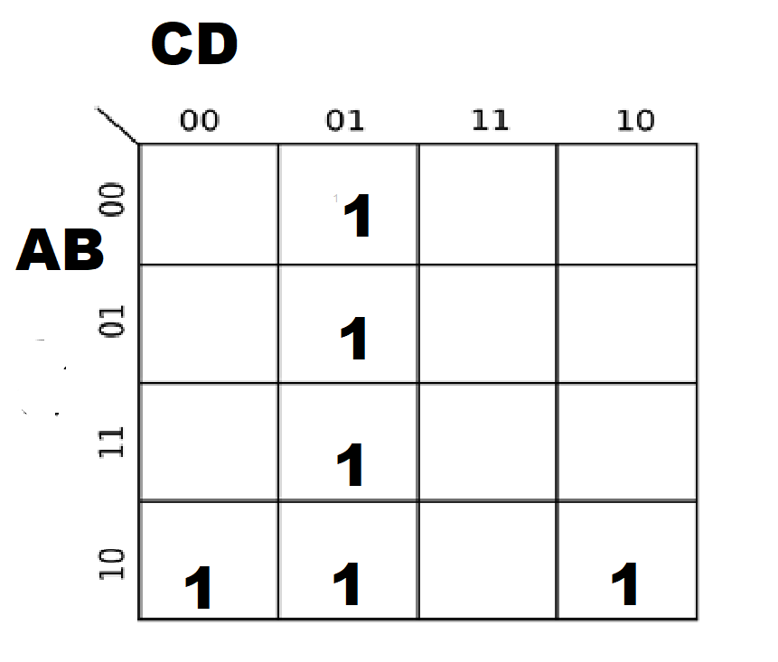

Truth Table

|  |  |  |  |  |
| --- | --- | --- | --- | --- |
| A | B | C | D | F |
| 0 | 0 | 0 | 0 | 0 |
| 0 | 0 | 0 | 1 | 1 |
| 0 | 0 | 1 | 0 | 0 |
| 0 | 0 | 1 | 1 | 0 |
| 0 | 1 | 0 | 0 | 0 |
| 0 | 1 | 0 | 1 | 1 |
| 0 | 1 | 1 | 0 | 0 |
| 0 | 1 | 1 | 1 | 0 |
| 1 | 0 | 0 | 0 | 1 |
| 1 | 0 | 0 | 1 | 1 |
| 1 | 0 | 1 | 0 | 1 |
| 1 | 0 | 1 | 1 | 0 |
| 1 | 1 | 0 | 0 | 0 |
| 1 | 1 | 0 | 1 | 1 |
| 1 | 1 | 1 | 0 | 0 |
| 1 | 1 | 1 | 1 | 0 |

Expression

F = (A’B’C’D) + (A’BC’D) + (AB’C’D’) + (AB’C’D) + (AB’CD’) + (ABC’D)